|  |  |
| --- | --- |
| Assessment Title | Policy & Procedure Update Assignment (Grievance & Privacy with Role Play) |

## Competency Details

|  |  |
| --- | --- |
| Unit code/s and title/s | ICTICT532 Apply IP, ethics and privacy in ICT environments |
| Qualification code/s and title/s | ICT50220 Diploma of Information Technology |
| Business unit/Work group | Business and Art / IT Studies |

## Instructions

|  |  |
| --- | --- |
| Method/s of assessment | Observation and Questioning (Role Play) & Product (Written) |
| Overview of assessment | This assessment is a practical assessment to identify and document organisation IP, ethics and privacy policy procedures non-compliance infringements at ITWorks. |
| Task/s to be assessed | This assessment will require you to complete the following tasks   * Task 1 – Use feedback to update the grievance procedure, release the grievance procedure to staff & monitor COE update implementation and get staff feedback * Task 2 – Define what constitutes a ‘notifiable data breach’, determine how ITWorks would act if a ‘notifiable data breach’ occurs & produce a written report (email) for the updated procedure * Task 3 – Conduct a role play relating to IP, ethics and privacy policies and procedures at ITWorks involving a potential COE breach & produce a written report (email) about the role play * Task 4 – submit a completed COE update and interview to review |
| Time allowed | Refer to your schedule for submission dates |
| Location of assessment | Assessment can be completed anywhere with access to the resources required. (see Resources Required section below) |
| Decision making rules | To receive a satisfactory outcome for this assessment you must complete all parts correctly.  Word counts are provided as guidance only. |
| Assessment conditions | This assessment must be demonstrated in a workplace or simulated environment where the conditions are typical of those in a working environment in this industry.  This includes access to:   * required organisational policies, codes of practice, legislation and standards of documentation * workplace documentation and resources * IP case studies and, where possible, real situations * hardware and software applicable to applying legislative and organisational policies.   This is an unsupervised assessment and you may access any required resources.  This is not group work and must be completed as an individual. |
| Resources required | To complete this assessment, you will require the following:   * Access to Learn with Internet access & Learn resources * ITWorks Documentation * Microsoft Teams to record role play(s) * O365 or similar for documentation and to draft email(s) * Your own PC or Laptop * Windows snipping tool |
| Result notification and reassessment information | You will be provided feedback and the result for your assignment on TAFESA Learn. You will be and given the chance to resubmit with required corrections only once.  Refer to the TAFE SA assessment policy for more information <https://www.tafesa.edu.au/apply-enrol/before-starting/student-policies/assessment> |

**Policy & Procedure update assignment (Grievance & Privacy with role play)**

**Task 1: Grievance procedure**

1. Following your development work on a new ITWorks ‘grievance procedure’ (assignment #1), ITWorks have provided the following feedback:

*“Thank you for your work on the new ITWorks grievance procedure. We really like what you’ve done and we think you’re on the right track. We’d like you to review further though, can you please clarify if the new grievance procedure includes the following:*

* *a notification of an opportunity for an ‘informal grievance’ to be an option and include the details involved*
* *a requirement that a final signoff form is a part of the process and includes:*
  + *details of any & all outcomes*
  + *listing(s) of any actions/changes going forward*
  + *a section for all parties to sign*

*We feel that the information above is essential, if it is currently not in the new ITWorks grievance procedure please ensure that it is added.”*

You are to respond by drafting an email to all ITWorks management to inform them of your completed grievance procedure review and briefly explain what changes you have made (approx. 80 words & DO NOT SEND EMAIL!)

EMAIL DRAFT SCREENSHOT   
(please make the screenshot as legible to read as possible/reasonable): 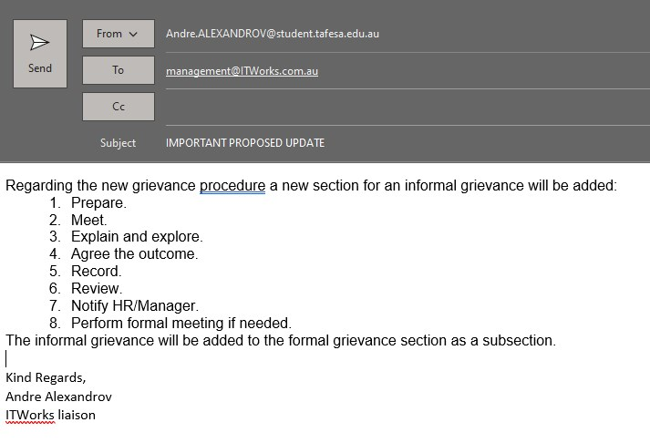

1. Scenario update: ITWorks management have approved and signed off on your proposed ‘grievance procedure’ and want it to be distributed to all ITWorks staff. Draft an email to all ITWorks staff to inform them of your new procedure and briefly explain what the procedure is (approx. 30 words & DO NOT SEND EMAIL!)

EMAIL DRAFT SCREESHOT   
(please make the screenshot as legible to read as possible/reasonable):

1. Scenario update: You have been asked to monitor ITWorks staff to see if they are abiding by the changes you have implemented to the ITWorks COE (assignment #1 question #7).  You decide to draft an email (approximately 50 words in total) to all staff to
   1. gauge how the changes are being accepted and
   2. ask for feedback on the changes

EMAIL DRAFT SCREENSHOT  
(please make the screenshot as legible to read as possible/reasonable):

**Task 2: privacy procedure update**

**Scenario**

In your role as ‘ethical liaison’ you have been notified that there some updates by the OAIC to the regulatory compliance requirements for ‘Notifiable Data Breaches scheme’. You have been asked to draft an update to the ITWorks COE that reflects the update.

1. You must list at least two actions defining what a data breach is at ITWorks that will be added to the COE (approximately 50 words in total)

ANSWERS:

1. You must also define a procedure (approximately 50 words in total) listing how a detected data breach is handled at ITWorks including:
   1. what is required to happen immediately (at least three steps required)
   2. when reporting to the OAIC is required (four answers required)

ANSWER DATA BREACH PROCEDURE:

* + 1. Immediate steps include…
    2. Report to the OAIC if:

1. Following your work updating the ITWorks COE in this task, draft an email to all ITWorks management to inform them of your proposed updates in the ‘ITWorks Code of Ethics and Professional Conduct’ document and explain the updates (approx. 80 words & DO NOT SEND EMAIL!)

EMAIL DRAFT SCREENSHOT   
(please make the screenshot as legible to read as possible/reasonable):

**Task 3: role play**

**Assessment context**

You are working in the role of Service Desk Analyst on the Service Desk for ITWorks. In your role you are supporting the employees of ITWorks and external clients and assisting them to resolve their ICT service calls to the Service Desk and receiving feedback from them on your service.

You communicate directly with clients and employees to:

* Log service calls
* Informing the clients of the progress of their service call
* Resolve the service call or escalate it for immediate action
* Communicate policy changes to ITWorks employees
* Communicate issues to ITWorks management

**Your Task**

In this task you are to receive a service desk call and you must comply with the ‘ITWorks Code of Ethics and Professional Conduct’. You are to identify incidences of non-compliance infringements and if a breach of the COE occurs. You must take notes and in due course communicate the relevant documentation to the appropriate stakeholders.

Role play notes:

You will need to take a phone call from a member of the public (book a time with your lecturer in class or another time that suits). This does not have to be an actual phone call, it can be face-to-face, online, etc. You must follow ITWorks service call norms.

**Service call details**

Part 1 – Service Call Role Play:

As part of the role play you must conduct the service call with a member of the public approximately 3-7 minutes in length

* + you are a service desk ‘support analyst’ at ITWorks
  + your lecturer plays the role of an unknown caller

Interact throughout the call to obtain and record:

* 1. who is calling?
  2. what they want or are trying to do?
  3. why do they want what they are calling for?
  4. if the client is not happy suggest other option or solutions the caller could try
  5. seek feedback if client not satisfied/happy

Part 2 – Documentation and Inform IT Work Management:

You are to draft an email to IT Work management of approximately 100 words (in total). This email must address the scenario issues above and cover the following:

1. A brief description of the service call incident
2. Notify management of any possible breaches and recommended actions

EMAIL DRAFT SCREENSHOT   
(please make the screenshot as legible to read as possible/reasonable):

**Task 4: COE update**

Part 1 – COE Documentation Update

Scenario update: ITWorks management have decided to review your performance in your new role as ‘ethical liason’. You must submit a complete copy of your updated COE for review in the space provided below, you should ensure that all updates that you have made are included (ie from both assessments in this course). Make sure that all updated sections are highlighted blue.

ANSWER (insert copy of complete/updated COE document below):

Part 2 – COE Update Interview

**Your Task**

In this task you are to discuss your COE updates with your manager, you must book a time with your manager (ie your lecturer) in class or another time that suits. This does not have to be an actual phone call, it can be face-to-face, online, etc. You must follow ITWorks service call norms, the call with your manager will be approximately 3-7 minutes in length.

NOTE: this conversation will take place after your assignment has been submitted to learn and assessed so that your lecturer has a copy of your updated COE from ‘Part 1’ above.

You are to interact with your manager throughout the call to:

1. discuss all COE updates
2. elicit your managers views and ideas on the updates you have made
3. ask for feedback and discuss future updates and ongoing improvement